

***Udston Primary School***

***Thornhill Road,***

***Hillhouse,***

***HAMILTON ML3 9PS***

***Telephone 01698 823677***

***Fax: 01698 828066***

***Office email address:*** [***gw14udstonpsoffice@glow.sch.uk***](mailto:gw14udstonpsoffice@glow.sch.uk)

***School Web Address:*** [***www.udston-pri.s-lanark.sch.uk***](http://www.udston-pri.s-lanark.sch.uk)

***Learn together, Laugh together, Achieve together***

**Introduction**

U

dston Primary School is one of 124 primary schools throughout South Lanarkshire Council.

South Lanarkshire Council is the fifth largest authority in Scotland. It covers the following main areas; Clydesdale in the south which features extensive rural areas, Cambuslang, Rutherglen, Blantyre and Uddingston to the north as well as the towns of East Kilbride and Hamilton.

The Council’s Plan Connect sets out the Council’s Vision to “improve the quality of life for all within South Lanarkshire”.

For Education Resources this means delivering services of the highest quality as well as striving to bridge the gap. It is about continually improving the services for everyone at the same time as giving priority to children, young people, families and communities in most need. The priorities for schools and services are set out in the Education Resources Plan which confirms the commitment to provide better learning opportunities and outcomes for children and young people.

The context for service delivery in Education Resources takes account of major national and local developments. These include a commitment to implement all aspects of the national programme, Curriculum for Excellence (CfE); a commitment to work in partnership with colleagues to meet the challenges of ‘Getting it Right for Every Child’; and an awareness of the need to seek continuous improvement as we embark on a Journey to Excellence. Locally, the community plan, Stronger Together and the ambitious outcomes for children within Education Resources’ framework of core policies help to inform the Resources Plan.

The aims of South Lanarkshire Council, Education Resources are shown on the back cover of the handbook.

It is hoped that with your support and the support of other parents that the school can work together in creating an environment where children can be successful learners, confident individuals, effective contributors and responsible citizens.

Curriculum for Excellence has now been introduced across Scotland for all 3-18 year olds – wherever they learn. It aims to raise standards, prepare our children for a future they do not yet know and equip them for jobs of tomorrow in a fast changing world.

Curriculum for Excellence enables professionals to teach subjects creatively, to work together across the school and with other schools, to share best practice and explore learning together. Glow, Scotland’s unique, world-leading, online network supports learners and teachers in this and plans are already in place for parents across the country to have access to Glow.

Teachers and practitioners will share information to plan a child’s ‘learning journey’ from 3-18, helping their progression from nursery to primary, primary to secondary and beyond, ensuring the change is smooth. They’ll ensure children continue to work at a pace they can cope with and with challenge they can thrive on.

Curriculum for Excellence balances the importance of knowledge and skills.

Every child is entitled to a broad and deep general education, whatever their level and ability. Every single teacher and practitioner will be responsible for literacy and numeracy – the language and number skills that unlock other subjects and are vital to everyday life.

It develops skills for learning, life and work to help young people go on to further study, secure work and navigate life. It brings real life into the classroom, making learning relevant and helps young people apply lessons to their life beyond the classroom. It links knowledge in one subject area to another, helping children understand the world and make connections. It develops skills so that children can think for themselves, make sound judgements, challenge, enquire and find solutions.

There will be new ways of assessing progress and ensuring children achieve their potential. There are new qualifications for literacy and numeracy since 2012/13, and new National 4 and 5 qualifications from 2013/14. Our well regarded Access. Highers and Advanced Highers will be updated to take account of and support the new approaches to learning and teaching.

**Changing Qualifications Framework**

**SCQF SQA National ASQ Standard New Qualifications**

**Qualifications Grades**

7 Advanced Higher Advanced Higher

6 Higher Higher

5 Intermediate 2 S G Credit National 5

4 Intermediate 1 S G Credit National 4

3 Access 3 S G Foundation Access 3

2 Access 2 Access 2

1 Access 1 Access 1

There’s personal support to help young people fulfil their potential and make the most of their opportunities with additional support wherever that’s needed. There will be a new emphasis by all staff on looking after our children’s health and wellbeing-to ensure that the school is a place where children feel safe and secure.

Ultimately, Curriculum for Excellence aims to improve our children’s life chances, to nurture successful learners, confident individuals, effective contributors, and responsible citizens, building on Scotland’s reputation for great education.

Useful websites:

[www.Itscotland.org.uk/parentzone/cfe](http://www.Itscotland.org.uk/parentzone/cfe)

[www.LTScotland.org.uk/commstoolkit](http://www.LTScotland.org.uk/commstoolkit)

[www.Itscotlan.org.uk/learningteachingandassessment](http://www.Itscotlan.org.uk/learningteachingandassessment)

**Educational Aims**

O

ur aims are to provide an education that will help all pupils to achieve their potential academically, physically, aesthetically and morally; to learn to live and work harmoniously with their peers and have respect for the attitudes and feelings of others. By doing this we hope to help pupils acquire the knowledge and skills relevant to a fast changing world which requires flexibility and adaptation; that they may take their place and play a useful part in their society.



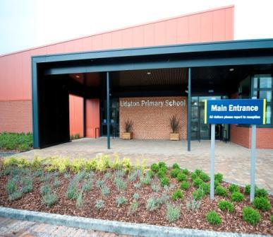**About our school**

**U**dston is a non-denominational school for boys and girls; covering

stages - Primary 1 to Primary 7 (i.e. pupils between 4 years and

12 years approximately). The present roll (December 2019) is 320

children and this roll has been steadily growing over the past few

years. The catchment zone covers part of the Hillhouse Area of

Hamilton as well as the Westcraigs Area of Blantyre.

As part of South Lanarkshire Council’s investment in improving school buildings, our new school building was opened to pupils on 18 October 2010. This new building provides a modern, well-equipped, stimulating and welcoming Teaching and Learning environment.

Our school was inspected, by HM Inspectorate of Education, in April 2010; and the report was published in May 2010. Particular Strengths of the School identified were:

* Outstanding Care and Welfare which creates a very positive environment for learning.
* Confident, well-behaved children who benefit from a wide range of opportunities for achievement.
* Partnership with parents and the wider community to support children’s learning and improve the school.
* Recent important improvements in providing high-quality learning experiences.
* Leadership for learning across the school.

An electronic copy of this report is available at [www.hmie.gov.uk](http://www.hmie.gov.uk)

As a result of the strong partnerships which exist amongst both teaching and support staff, the staff is a strength of the school. They are highly motivated, hardworking and committed to continuous improvement. A high level of nurturing from all staff leads to a strong ethos of pastoral care where achievement for all is promoted and celebrated throughout the school.

**Teaching Staff (December 2018)**



The Head Teacher is responsible for the welfare of staff and pupils, links with parents and the community, discipline, in-service and administration.

|  |  |
| --- | --- |
| Mrs Elaine Henry | Head Teacher |
| Mrs Rebecca Turnbull  Mrs Susie Drennan  Mrs Lesley Fearnside- Brogan | Depute Head Teacher  Acting Depute Head Teacher  Acting Principal Teacher |



**Class Teachers**

Janitors Mrs Nancy Gallacher & Mrs Marlyne Twaddle

|  |  |
| --- | --- |
| Primary 1 | Mrs A. Findlay-Conaghan |
| Primary 1a  Primary 2 | Mrs J. Brown  Mr D. Fotheringham |
| Primary 2/3 | Miss MacDonald & Mrs Smith |
| Primary 3 | Mrs V. Hamilton |
| Primary 3/4  Primary 4  Primary 4/5  Primary 5 | Mrs McCort and Mrs Reeks (on maternity leave) so  Mrs Brogan currently covering this.  Mrs J. Cowden  Mr D. Johnston  Mr S. Cooper |
| Primary 6  Primary 6/7  Primary 7 | Mrs M. Simpson  Miss C. Brown  Mrs L. Shaw |
| Equity Teacher  CCC Teacher | Mrs L. Fearnside-Brogan (Acting Principal Teacher)  Miss E. Arneil |
| Support Staff | Mrs I. Brogan (Team Leader)  Mrs M. Breakey  Mrs M. Burns  Mrs J. Fisher  Mrs F. Goulding  Mrs E. Orr  Mrs A. McMillan  Mrs N. Jamieson  Mrs C. McAulay  Mrs M. Kelly  Mrs J. Lee  Mrs R. Ramsay |
|  |  |
|  |  |

|  |
| --- |
| **Enrolment**  If your child is starting school for the first time you must enrol your child at their catchment school in January. Parents/Carers should bring the child’s birth certificate with them and two proofs of residence. It is a good idea to bring the child along at this stage so that they can begin to form an idea of what happens when you go to school.  Children will be invited back into school for our Welcome Sessions during the summer term before they start to meet our infant staff and begin to get know the other boys and girls who will be in their class. The sessions take place over May and June, and are part of our transition programme. One of the sessions includes what is involved in starting school. You will also get to know what to expect in the first few weeks and months.  If parents/carers want their child to go to another school, they must enrol in the first instance with their local school who will advise them of the next steps. Information leaflets that provide details on how to make a placing request are available from schools, QandA offices or by contacting Education Resources, Almada Street, Hamilton, telephone number 01698 454102. Completed forms should be returned as soon as possible to Education Resources, Almada Street, Hamilton ML3 OAE, unless completed online.  Enrolment date for 2019 is week commencing 13th January 2020.  **School Hours**    School Starts 9.00am  Morning Interval 10.30-10.45am  Lunch Break 12.15-1.00pm  Dismissal 3.00pm |

**Parental Involvement & Engagement**

Relationships with our parents/carers are strong. Parents are fully involved in their child’s learning through open days, staff/parent consultation, newsletters, class showcases of pupils’ achievements etc.

South Lanarkshire Council recognises the importance of parents as partners in the education of their child and has published a strategy entitled, ‘Making a difference – working together to support children’s learning’. This is available from the Council’s website: www.southlanarkshire.gov.uk

Parents, carers and family members are by far the most important influences on children’s lives. Children between the ages of 5 and 16 children spend only 15% of their time in school! Research shows that when parents are involved in their child’s learning, children do better at school and throughout life. Parental involvement can take different forms but we hope you share the same aims and agree that by working together we can be partners in supporting children’s learning.

As parents/carers we want you to be:

• Welcomed and given an opportunity to be involved in the life of the school;

• Fully informed about your child’s learning;

• Encouraged to make an active contribution to your child’s learning;

• Able to support learning at home;

*•* Encouraged to express your views and involved in forums and discussions on education

related issues.

**Your commitments**

We ask that you:

* Support and encourage your child’s learning
* Respect and adhere to the schools policies and guidance
* Let the school know if you change your mobile/telephone number and/or address
* Enjoy and take part in school activities
* Accept your responsibility to respect staff who work in the school and for the school to be proactive in taking forward its commitment to care for and educate your child.

To find out more on how to be a parent helper, or a member of the Parent Council just

contact the school or visit our website.

Some useful information contacts for parents to find out more on education are as follows:-

• Parentzone – www.parentzonescotland.gov.uk

• Engage Parent Forum – [www.engageforeducation.org](http://www.engageforeducation.org)

• National Parent Forum for Scotland – [www.educationscotland.gov.uk/parentzone](http://www.educationscotland.gov.uk/parentzone)

• South Lanarkshire Council – [www.southlanarkshire.gov.uk](http://www.southlanarkshire.gov.uk)

**Parent Council**

We have an established Parent Council who is involved in decision making within the school. They liaise with other parents to ensure that parents’ views are considered in all matters. They are responsible for organising and running fund raising events throughout the year. Regular Newsletters, from the Parent Council, outlining forthcoming events are sent out to all parents. The Board can be contacted through the school or by contacting the following office bearers:

Christopher Barclay (Chair)

Julie Whelan (Vice-Chair)

Margaret Murray(Secretary)

Liz Morrison (Treasurer)

We are grateful to all parents for the support they offer throughout the year.

Schools and establishments should be the first point of contact for parents who wish to discuss issues about their child. Our aim is to resolve issues at local level. Education Resources wishes to promote liaison among schools, members of Parent Councils, parents/carers and with other services. We wish to provide advice and support to Parent Councils, parents/carers.

Any enquiries and concerns received from parents are taken seriously. In order to ensure that enquiries are dealt with effectively contact should be made in the first instance with the school.

**School Ethos**

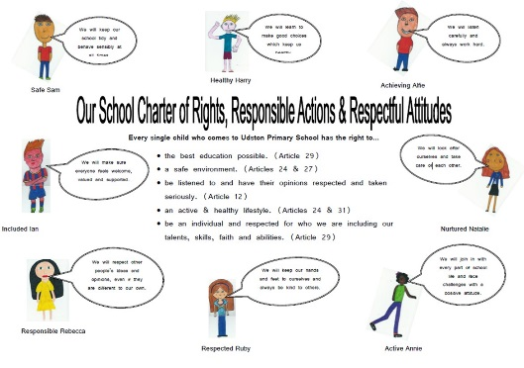We strive to embed the principles of the *United Nations Convention on the Rights of the Child* (UNRCR) and *Getting It Right For Every Child* (GIRFEC) at the heart of our school ethos to ensure pupils are aware of their rights, responsible actions and respectful behaviours and use these to make informed decisions. We developed a School Charter, and created characters known as the SHANARRI Family, which are based upon the Wellbeing Indicators outlined in GIRFEC, as well as the Articles contained in the UNCRC. This Charter is used to promote positive relationships, behaviours and attitudes throughout the school.

At Udston, we place a strong emphasis on celebrating and recognising the individual achievements and talents of all children. This is done in a wide range of contexts which reflect the interests of all our young people. We promote a safe, positive environment where our pupils can thrive, reflect on their successes and be the best they can be.

**Citizenship**



We promote Global Citizenship in many ways, one of which is through our commitment to Social Enterprise. This has been recognised through gaining a Social Enterprise in Schools Award two years consecutively, a first in Scotland, and also by winning the Scottish Youth Led Social Enterprise of the Year Award. We achieved our Level 1 Rights Respecting School Accreditation from UNICEF as a result of the work we have done to place children’s rights at the heart of the school’s ethos, policies and planning. We are committed to helping various charitable organisations including; Hamilton District Foodbank, Comic Relief, Sport Relief, UNICEF, Children in Need, the British Heart Foundation, and Cash for Kids. Our pupils are encouraged to regularly question their own and others’ assumptions and perceptions about people, places and issues and the important role they can play in influencing decision making. Teaching and learning about global citizenship focuses on educating our learners about local, national and global issues which affect them. Our children learn about fair and ethical trading and how they can take steps to live sustainably; this has been recognised through our recent Fair Active Award.

**Health and Wellbeing**

Health and Wellbeing is a priority and strength of the school and we use innovative approaches to empower our pupils to make positive decisions regarding their personal health and wellbeing. We have achieved and maintained our Gold Status as a Health promoting School.

**Food Education**

Following a successful Food for Thought grant award, we have been recognised by Education Scotland for our work in Food Education linking to national initiatives and working in partnership with local businesses to enhance learning.

**Extra-Curricular Programme**

At Udston, we have an extensive extra-curricular programme delivered either by staff in their own time or by local sports coaches. At the beginning of each school year, we ask our pupils which activities they would like to be included in our programme and try our best to cater to their needs and interests. The sporting activities we offer vary each term and have included; Girls’ & Boys’ Football; Netball; Athletics; Badminton; Run, Jump & Throw; Fun Fitness; Choir and Dance. We believe that school provides an excellent opportunity for children to develop an interest and passion for sport and physical activity. We have excellent links with our Active Schools Coordinator and local clubs in the community to ensure a clear pathway into sport should children wish to progress further.

[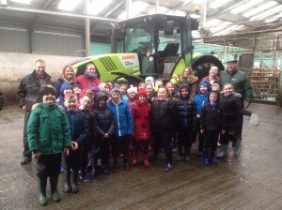](http://www.udston-pri.s-lanark.sch.uk/wp-content/uploads/2016/01/IMG_0280.jpg)We also provide a range of other extra-curricular activities including our annual school show club and choir.

Educational visits often take place throughout the year depending on the learning taking place in the classroom. Visits have included the Science Centre, Farms, Museums, Exhibitions, Libraries, and other places of interest.

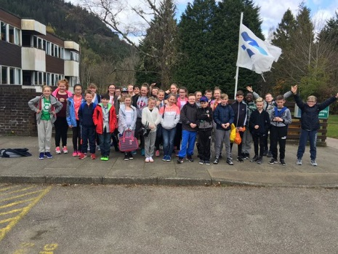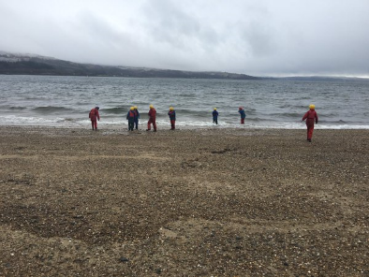Our Primary 7 pupils attend a 5 day residential trip to an Outdoor Centre such as Ardentinny where they experience a variety of exciting outdoor learning activities including rock hopping, gorge walking, canoeing, climbing and abseiling. The residential experience provides children with a unique context for learning in which they develop a range of skills including team working, problem solving and resilience.

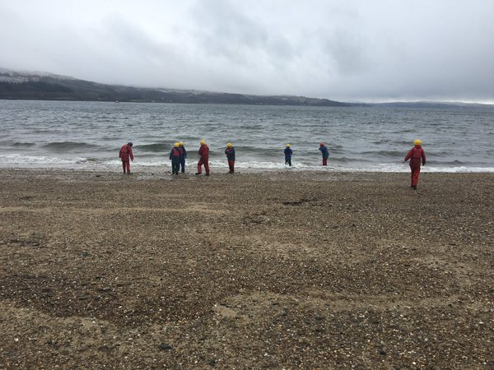**Celebrating Success & Achievements**

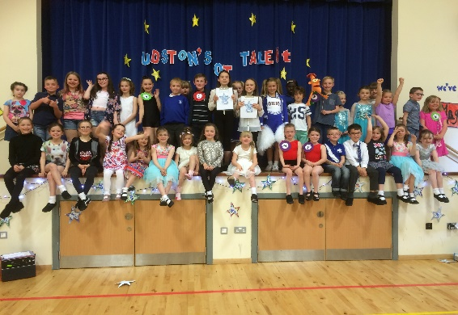We are committed to providing our children with a variety of contexts for learning and offer many opportunities for personal achievement. Our yearly whole school talent show – ‘Udston’s Got Talent’ - allows children to showcase their individual talents to an audience of pupils, staff, parents and the wider community.

We have weekly awards assemblies where pupils from each class receive a special certificate in recognition of their hard work throughout the week. We also celebrate a masterpiece from each class that is then displayed outside the gym hall. The assemblies are also used to share and celebrate any achievements or awards received outside of school.

**Udston United – Pupil Teams**

Curriculum for Excellence states that:

“Children and young people should be encouraged to contribute to the life and work of the school and, from the earliest stages, to exercise their responsibilities as members of a community. This includes opportunities to participate responsibly in decision-making, to contribute as leaders and role models, to offer support and service to others and to play an active part in putting the values of the school community into practice.”

We believe that all of our learners should feel valued and listened to and should have the opportunity to contribute their ideas and opinions within their classroom and in the wider life of our school. As such, each child from Primary 2-7 belongs to a pupil team which meet for a block of sessions to focus on a specific area of school development. We call this approach vertical learning as it involves pupils from different stages and ages working together. This gives our older pupils the opportunity to take on leadership roles and support the younger children in the team.

Our committees include;

[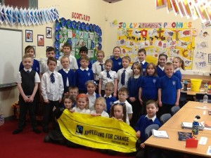](http://www.udston-pri.s-lanark.sch.uk/wp-content/uploads/2014/11/IMG_0352.jpg)

* Eco Committee
* Pupil Council
* Health & Wellbeing
* Website
* Community Links
* Fairtrade
* Social Enterprise & Global Citizenship
* Enterprise & Fundraising
* Sports for Schools
* World of Work

**Eco School**

As a three-time Green Flag awarded Eco School, we promote environmental awareness and encourage children, staff and the wider community to take positive action. Our Eco Warriors Team, which consists of a mixture of representatives from Primary 1-7, review and discuss the school’s action plan and decide on next steps.

**Learning Community**

A learning community is made up of schools and education establishments from the area including the secondary school, primary schools, early years establishments, early years partners and schools and bases which provide specialist additional support services. It is about working together to plan better outcomes for children and young people.

The learning community develops ways of working between establishments and with other agencies and organisations to ensure services are responsive, accessible and are delivered as effectively as possible.

Each Learning Community is managed by a Head of Education (Area).

The Head of Education for our area is Stewart Nicolson

Education Resources

Almada Street

HAMILTON

ML3 0AE

All the establishments and services in a Learning Community share priorities for improvement and are involved in the deployment of additional support to meet the needs of the child and family.

**The Curriculum**

Curriculum for Excellence is the name given to the new curriculum in Scotland for all children and young people aged 3-18. It is a forward looking, coherent, more flexible and enriched curriculum that provides young people with the knowledge, skills and attributes they will need if they are to flourish in life, learning and work, now and in the future.

The curriculum includes all of the experiences that are planned for children and young people to support the development of their skills, wherever they are being educated, for example in the family and community, pre-school centre, nursery and school. This broad, general education will allow them to become successful learners, confident individuals, responsible citizens and effective contributors to life in the 21st century.

In taking this forward our school will work closely with South Lanarkshire Education Resources and other services to enable Curriculum for Excellence to be fully embedded, ensuring the best possible education for all children and young people. We wish you to feel confident that your child is encouraged and supported to develop their literacy, numeracy and other skills whilst they attend our school. The curriculum areas are as follows:

* Expressive Arts
* Languages and Literacy
* Health and Wellbeing
* Mathematics and Numeracy
* Religious and Moral Education
* Science
* Social studies
* Technologies

If you want to know more about Curriculum for Excellence, please visit website [www.curriculumforexcellence.gov.uk](http://www.curriculumforexcellence.gov.uk) or [www.parentzonescotland.gsi.gov.uk](http://www.parentzonescotland.gsi.gov.uk)

Our learning and teaching activities are based on the outcomes and experiences in the guidelines that all schools have for Curriculum for Excellence.

|  |  |
| --- | --- |
| Level | Stage |
| Early | The pre-school years and Primary 1 or later for some. |
| First | To the end of Primary 4, but earlier or later for some. |
| Second | To the end of Primary 7, but earlier or later for some. |

**Health and Wellbeing**

Learning in Health and Wellbeing ensures that our children develop the knowledge and understanding, skills, capabilities and attributes which they need for mental, emotional, social and physical wellbeing now and in the future. Learning through health and wellbeing enables children to make informed decisions to improve their overall wellbeing, experience positive aspects of healthy living and activity for themselves, pursue a healthy lifestyle and establish a pattern of health and wellbeing which will be sustained into adult life.

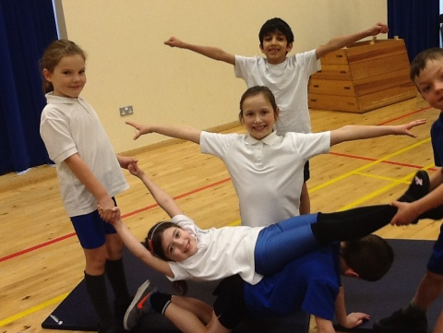**P.E.** - All classes participate in P.E. By making use of the outside space in our school, we ensure that all children have the opportunity to participate in P.E. for at least 2 hours each week. Dance, Gymnastics, Ball Handling and Athletics are all covered in the course of the year. The whole school Programme of Study for P.E. has enhanced the work being carried out, ensuring progression and continuity throughout the school.

P.7 pupils are given swimming instruction for part of the year.

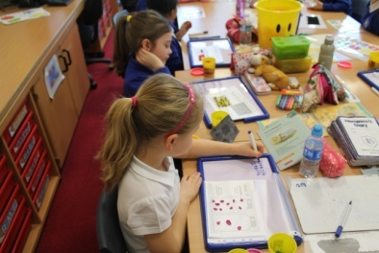

**Mathematics and Numeracy**

Mathematics is important in our everyday life, allowing us to make sense of the world around us and to manage our lives. Using mathematics enables us to model real-life situations and make connections and informed predictions. It equips us with the skills we need to interpret and analyse information, simplify and solve problems, assess risk and make informed decisions.



Mathematics plays an important role in areas such as science or technologies, and is vital to research and development in fields such as engineering, computing science, medicine and finance. Learning mathematics gives children access to the wider curriculum and the opportunity to pursue further studies and interests.

At all stages, teachers will employ Active Learning/Interactive strategies to teach mathematical concepts in order to ensure that the children are fully engaged in their learning.

We believe that it makes sense, for pupils, to learn how to make wise decisions on which method - mental, written or using a calculator - is appropriate in particular circumstances. However, we also believe that the calculator should not be allowed to provide unnecessary support, or substitute for the development of personal proficiency.

At all stages, on a daily basis, oral number skills are practised with whole class groups. The Number Talks programme has been introduced across the school this session. It is hoped by continuing with this practice, our children will develop quick and accurate mental agility.

Teacher-made resources, Smartboard programmes, including Education City and EasiMaths, and Scottish Heinemann and TeeJay materials are the core resources used.

**Language and Literacy**

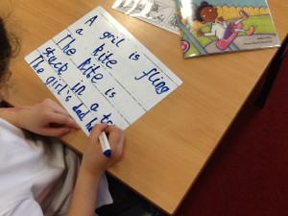

Language and literacy are of personal, social and economic importance. Our ability to use language lies at the centre of the development and expression of our emotions, our thinking, our learning and our sense of personal identity. Language is itself a key aspect of our culture. Through language, children can gain access to the literacy heritage of humanity and develop their appreciation of the richness and breadth of Scotland’s literary heritage. Children encounter, enjoy and learn from the diversity of language used in their homes, their communities, by the media and by their peers.

Literacy is fundamental to all areas of learning, as it unlocks access to the wider curriculum. Being literate increases opportunities for the individual in all aspects of life, lays the foundation for lifelong learning and work, and contributes strongly to the development of all four capacities of Curriculum for Excellence.

**Active Literacy Programme**

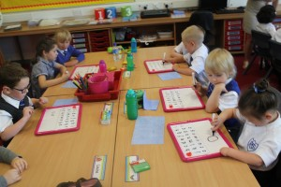All teaching staff have been trained in using North Lanarkshire Council’s Active Literacy Programme. Active Literacy is an approach which is underpinned by evidence based research and focuses on reading, writing, talking and listening. Through this approach, children are engaged in active and challenging tasks using a variety of exciting materials including magnetic letters and boards. In the early stages of Phonics and Spelling, children are taught to read, make, blend and write words using the ‘five finger approach’ Say, Make/Break, Blend, Read, Write. Children also learn and identify strategies which help them read and spell common and tricky words. As they progress through the school, the programme builds on what has been taught before and children are encouraged to continue to develop strategies for help with spelling and are also introduced to spelling rules.

In the infant stages of the school, the Reading element of Active Literacy does not consist of using a reading scheme. Instead a book banded approach is adopted. Books from a range of publishers and authors, covering fiction and non-fiction, with variation in style and content, are graded in a colour system. The children can then be working on any book in the colour banding, therefore being exposed to a wide variety of books. As children move up the school, the reading programme focuses on developing children’s Higher Order Thinking and Comprehension Skills using novels and non-fiction texts.

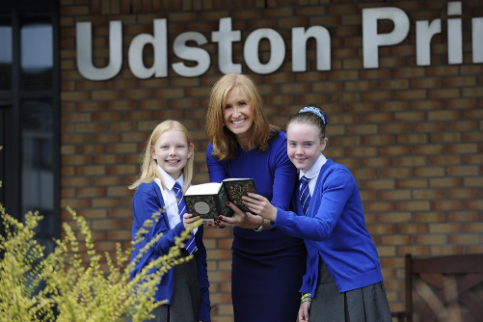**School Library**

In August 2016, we officially opened our brand new Library with the help of BBC Reporting Scotland newsreader, Jackie Bird. Our Library was funded through grants from Education Scotland and the Co-Op Local Fund as well as school and Parent Council fundraising efforts. The Library is home to thousands of fiction and non-fiction books covering a range of genres, themes and interests. All children visit the Library on a weekly basis and borrow books to take home, it is also open to pupils during lunchtimes. The Library provides all children with the space and resources required to read for enjoyment and research their interests in an engaging and stimulating environment.

**Social Studies**

[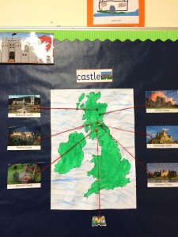](http://www.udston-pri.s-lanark.sch.uk/wp-content/uploads/2015/08/IMG_9143-e1453392460551.jpg)Through Social studies, children develop their understanding of the world by learning about other people and their values, in different times, places and circumstances; they also develop their understanding of their environment and of how it has been shaped. As they mature, children’s experiences will be broadened using Scottish, British, European and wider contexts for learning, while maintaining a focus on the [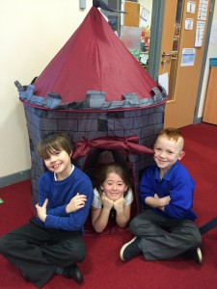](http://www.udston-pri.s-lanark.sch.uk/wp-content/uploads/2015/08/IMG_9149-e1453392172517.jpg)historical, social, geographic, economic and political changes that have shaped Scotland. Children will learn about human achievements and about how to make sense of changes in society, of conflicts and of environmental issues. With greater understanding comes the opportunity and ability to influence events by exercising informed and responsible citizenship.

[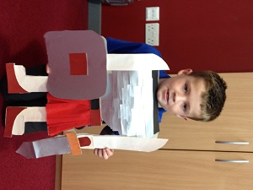](http://www.udston-pri.s-lanark.sch.uk/wp-content/uploads/2015/02/IMG_0468.jpg)

**Expressive Arts**.

The inspiration and power of the arts play a vital role in enabling our children to enhance their creative talent and develop their artistic skills.

By engaging in experiences within the Expressive Arts, our children will recognise and represent feelings and emotions, both their own and those of others.

E

xpressive Arts is the broad heading given to Music, Art and Drama and all of our children have opportunities to develop skills and enjoyment in all of these areas.

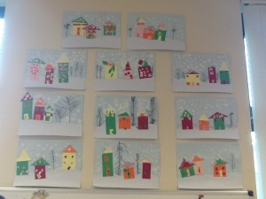

**Music** - All children are given opportunity to sing and play tuned and untuned percussion instruments as part of their learning in Music. We access a range of resources, including ABC Music Online, which provide opportunities for learning and enjoyment.

**Art** - All children experience a variety of techniques and materials used in Art; and in the senior classes, children are encouraged to appreciate the work of well-known artists. We have introduced a programme of study, which ensures progression and continuity across all aspects; and this programme will be developed, at all stages, in the coming sessions.



**Drama** - All children participate in Drama activities using a variety of contexts for learning. Often these activities arise from language discussion work or learning across the curriculum within the class.

[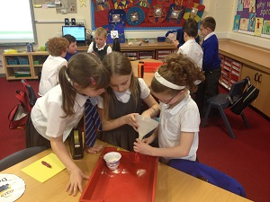](http://www.udston-pri.s-lanark.sch.uk/wp-content/uploads/2015/02/IMG_0629.jpg)**Sciences -** Through learning in the sciences our children develop their interest in, and understanding of, the living, material and physical world. They engage in a wide range of collaborative investigative tasks, which allows them to develop important skills to become creative, inventive and enterprising adults in a world where the skills and knowledge of the sciences are needed across all sectors of the economy. Each year, to tie in with National Science Week, all classes use the sciences as a focus for their learning.

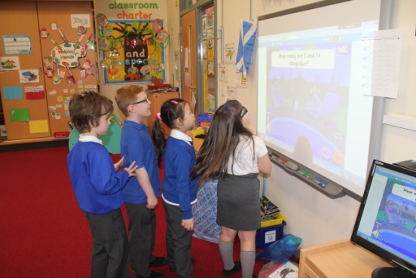**j0205582Technologies -** The experiences gained, by our children, through learning in the technologies, provides scope for developing technological skills, knowledge, understanding and attributes through creative, practical and work-related activities. These can be applied in business, computing science, food, textiles, craft, design, engineering and graphics.

Digital Learning is our CCC subject being taught across the school this year, which is having a very positive impact on our learners’ skills already. Our ICT suite is timetabled throughout the day. We have iPads, Chrome Books and Laptops which enhance and ‘bring to life’ the learning experiences of all of our children. All pupils will have access to the internet and have e-mail facilities. Every classroom has an Interactive Smartboard and internet access.

**Spiritual, Social, Moral and Cultural Values**

W

e hope to foster an awareness of right and wrong and a spirit of kindness towards each and every member of our community. Religious education is taught in accordance with the doctrine and traditions of Christianity. We also hope to develop within the children an awareness of and respect for, the beliefs of other cultures as well as their own.

Currently, a whole-school programme covering Christianity and other World Religions is being delivered. Education Resources has produced guidelines on Religious Observance Policies and these are available in all establishments.

Parents may request that their children be permitted to be absent in order to celebrate recognised religious events. Advance notice should be provided to the school when children will be absent. Appropriate requests will be granted and the pupil noted as an authorised absentee in the register.

In an attempt to make religious teaching relevant to the children, we hold regular assemblies where children have the opportunity to come together as a whole school.

Hillhouse Parish Church has traditionally had strong links with the school and the Reverend Christopher Rankine, regularly shares events, assemblies and religious observance.

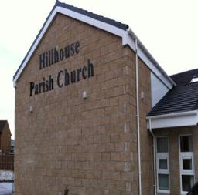

**Rights of Parents / Carers**

Scottish Government Ministers consider that religious observance complements religious education and is an important contribution to pupils’ development. It should also have a role in promoting the ethos of a school by bringing pupils together and creating a sense of community.

There is a statutory provision for parents to withdraw children from participation in religious observance. This right of parents’ wishes will be respected.

Where a child is withdrawn from religious observance, schools will make suitable arrangements for the child to participate in a worthwhile alternative activity.

**Equalities**

Integral to this guidance is the principle of mutual respect. The diversity of belief and tradition provides an ideal context in which pupils can learn about, and so learn from, what is important in the lives of themselves and others. South Lanarkshire’s guidance recognises and welcomes diversity and promotes respectful understanding.

Parents may request that their children be permitted to be absent in order to celebrate recognised religious events. Advance notice should be provided to the school when children will be absent. Appropriate requests will be granted and the pupil noted as an authorised absentee in the register.

**Equal Opportunities and Social Justice**

A

t Udston we endorse the aims of the Education Resources’ Purpose Statement, to offer education of the highest quality by:



**Encouraging learners to achieve their maximum potential**

**ensuring equality of opportunity.**

O

ur aims are:

**To create an equal opportunities climate where**

**every individual is treated with respect and can learn to work**

**in the knowledge that his/her contribution is valued.**

**To offer a learning and working environment**

**where individuals can grow in self-esteem.**

**To deliver a curriculum with learning activities**

**which match the interests and abilities of the full range of learners**

**and which promote the inclusion of all identifiable groups.**

**To show a commitment to counteracting prejudice**

**and injustice in whatever form it may take.**

**To give equal encouragement to boys and girls**

**in all aspects of their development**.

Schools take seriously any reported racist incidents. Within the school’s approach to promoting positive discipline a record of all racist incidents is maintained and each incident fully investigated.

Schools are required to notify the local authority of all racist incidents.

Schools and education establishments have a legislative duty to undertake an assessment of equality and diversity. This is the process of systematically assessing and consulting on the effects that a policy, process or strategy is likely to have on different groups in the community who might experience disadvantage/barriers in accessing services. The process includes monitoring the actual effects of the policy once it is put into practice. Policies do not affect everyone in the same way. By assessing in the early stages, any adverse impact can be identified and minimised.

We have undertaken the following impact Assessment: Gender Equality, Race Equality and Disability Equality. Copies of these can be obtained from the office.

The Equality Coordinator for the school is Mrs Henry (Head Teacher).

**Learning, Teaching and Assessment**

Your child will be assessed continuously in class and the starting point will be from what your child has already been taught and learned. This will inform the teacher’s future planning and teaching.

Our teachers are skilled in using a range of formative and summative strategies, which allow the children to become reflective learners. They become involved in the setting and reviewing of learning targets, where they have the opportunity to discuss progress, strengths and development needs with their teachers.

We also monitor and track pupil progress at regular points throughout the year. This information is based on a range of learning evidence and professional teacher judgement. Additionally, we administer the Scottish National Standardised Assessments for P1, P4 and P7, as currently required.

**Reporting**

U

dston Primary recognises that good teamwork among parents, children and schools is the key to a successful education for your child.

Reporting will be ongoing and will comprise of a range of activities which includes; Meet the Teacher session, curriculum workshops, Sharing the Learning Events twice yearly, final reports, and twice yearly parent/carer visits. This year we have also introduced Showcases for each class.

Our school website and Twitter page are regularly updated with class information and school news. We also have our school app, which is very well used by families.

We provide parents with reports so that you can see what your child is doing and how they are progressing in their learning. In addition, our parents’ meetings offer you the opportunity to discuss how your child is doing in school and what your child has been learning. You can contact the school at any time to discuss any matter that you wish to raise.

Our ‘pupil reports’ will help you to get to know more about the curriculum which each child follows and will describe strengths, achievements and areas for development so you know what encouragement and support you can give.

We welcome any comments or additional information from parents to help us provide the best possible education for your child.

**Transitions**

Pupils normally transfer from primary to secondary school between the ages of 11½ and 12½, so that they will have the opportunity to complete at least 4 years of secondary education. Arrangements are made by the school to transfer children to the associated secondary school as determined by their home address. Parents of P7 children will be informed of the transfer arrangements made for their child to attend secondary school.

We will also provide you with information at this time and on events designed to let P7 children visit the secondary school, meet up with other P7 children from other schools so that the transition period is as smooth as possible.

Normally children attend the school in their catchment area. However, there are times when parents may wish their children to go to other schools. If you wish your child to go to another school then you may make what is known as a ‘placing request’. If you live in South Lanarkshire and decide to submit a ‘placing request’, we are unable to reserve a place in your catchment school until the Council have made a decision on the ‘placing request’. Please note if your ‘placing request’ application is unsuccessful and all places at your catchment school are filled you will be offered a place at the next nearest appropriate South Lanarkshire School.

Please note that if an application for a ‘placing request’ is successful then school transport is not provided.

If you move out with your catchment primary school a ‘request to remain form’ must be completed. If you move out with your catchment primary, this may affect your right to transfer to the associated Secondary School. Please note the secondary school is determined by the pupil’s permanent home address and chosen denomination. If you require further information, please contact Education Support Services on **0303 123 1023**.

Our pupils normally transfer to:

Calderside Academy

Blantyre

Telephone No 01698 717180.

Head teacher – Mr S. Dodds

**Support for Pupils**

**Getting it right for every child, (GIRFEC)**

Getting it right for every child is a partnership commitment to ensure that your child has the best possible start in life, based on a shared understanding of their wellbeing. Most of the time, most children get all of the support they need from their families, with help from universal education and health services. When needed, the named person in education can offer help and support to children and families to make sure that the child’s wellbeing is developing and that any issues are being addressed. At our school the named person is Mrs Henry, headteacher.

If you have any concerns about your child’s wellbeing, you can speak to the named person who will work with you to ensure that your child gets the right help from the right person at the right time. Your school will let you know who this is. It is likely to be the Head Teacher in a primary school and a principal teacher (pupil support) in Secondary.

More information can be found on: [www.girfecinlanarkshire.co.uk](http://www.girfecinlanarkshire.co.uk) and [www.scotland.gov.uk/gettingitright](http://www.scotland.gov.uk/gettingitright)

**Support for All (Additional Support Needs)**

Pupils’ pace of learning varies and may require different levels of support with their learning. Support is therefore given support within the class environment. Often support is also offered by Support Staff to give additional help to these children in small group situations; or by Mrs Farrell, Specialist Support Teacher, who works in school one day each week.

Where the learning need is more specific, parents are invited to discuss these before other agencies, such as psychological services, are involved in a supportive role.

Mrs Henry co-ordinates Learning Support; and additional support is provided by Mrs Farrell, Specialist Support Teacher.

South Lanarkshire Education resources have published a series of leaflets which cover information for parents and carers about the Additional Support for Learning Acts. These areavailable through the school or on the South Lanarkshire Council website www.southlanarkshire.gov.uk. The leaflets are:

• The Additional Support for Learning Act

• Requesting an Assessment

• Planning for Learning – ASP

• Planning for Learning – CSP

• Transitions

• Future Planning

• Information for Parents and Carers about moving on from school.

• Inclusive Education

• ICT Assessment

• Visual Impairment Support

• Early Years Specialist Support

• Independent Adjudication

Enquire is funded by the Scottish Government to provide information on the framework for supporting children who require additional support for learning and to encourage positive partnerships between families, schools and local authorities to ensure children get the right support.

Enquire – the Scottish advice service for additional support for learning

Enquire offers independent, confidential advice and information on additional support for learning through:

Phone Helpline: 0345 123 2303

Address: Enquire

Children in Scotland

Rosebery House

9 Haymarket Terrace

Edinburgh

EH12 5EZ

Email Enquiry service: [info@enquire.org.uk](mailto:info@enquire.org.uk)

Advice and information is also available at www.enquire.org.uk

Enquire provides a range of clear and easy-to-read guides and fact sheets including The parents’ guide to additional support for learning.

**Attachment Strategy for Education Resources**

Attachment – what we do to support children and young people

South Lanarkshire Council Education Resources is committed to improving outcomes for children and young people by creating emotionally supportive learning experiences in our nurseries and schools.

The Education Resources Attachment Strategy was launched in March 2019 and supports the action in the Getting It Right for Every Child in South Lanarkshire’s Children Services Plan 2017-20 – ‘Develop an attachment strategy and to inform training for staff working with early years to secondary aged children and young people on attachment-informed practice’.

What does it set out to do?

The aim of the strategy is to promote better experiences of attachment for South Lanarkshire’s children and young people and to ensure that all education practitioners understand the importance of attachment and how positive relationships can make a difference to outcomes.

How can I find out more?

South Lanarkshire Council Education Resources have published a series of leaflets and posters for parents/carers which aim to share information on attachment theory and on how this can inform the ways in which we support children and young people.

These are available from schools and we have plans to make them available on-line.

**School Improvement**

Each year staff, in consultation with pupils and parents, identify school improvement priorities which help to improve teaching standards and provide pupils with engaging learning experiences. This year’s priorities include;

* In line with the benchmarks for numeracy and mathematics, we will continue to review and develop a progressive planning framework for learning, teaching and assessment, and moderation across all levels, which ensure high quality experiences for all learners.
* We will align our existing active literacy programme with the benchmarks for literacy and English, ensuring progressive coverage of core learning and skills.
* All aspects of health and wellbeing will be strengthened, in line with the benchmarks, through the adoption of the Healthy in Schools Framework for planning and assessment across the school.

A copy of the school’s full Improvement Plan is available via our school website www.udston-pri.s-lanark.sch.uk.

**School Meals**

Healthy eating is something that the school supports and a range of meals are available at lunchtime that meet the Schools (Health Promotion and Nutrition) (Scotland) Act 2007 and the Nutrient Requirements for Food and Drink in Schools (Scotland) Regulations 2008.

The menu consists of a three course meal and all meals include fresh chilled drinking water and milk will be available for those pupils entitled to free school meals through the free school meal eligibility scheme at morning break or lunchtime. Milk is also available for purchase to those pupils wishing to buy at morning break and lunchtime. The children also have access to unlimited bread, salad and vegetables to supplement their meal.

Pupils in:

• Primary 1 - 3 receive a free school lunch.

• Primary 4 - 7 meal cost is £1.70

**Free School Meals**

Children of parents who receive the following benefits are entitled to a free lunchtime meal for their child

* Income Support, Universal Credit (where your take home pay is less than £610 per month), Job Seeker’s Allowance (income based), Employment and Support Allowance (income related), Working Tax Credit and Child Tax Credit (where your gross annual income does not exceed £6,900 as assessed by the HM Revenues and Customs), Child Tax Credit Only (where your gross annual income does not exceed £16,105 as assessed by the HM Revenues and Customs) or receive support under Part VI of the Immigration and Asylum Act 1999.

If you are in receipt of Housing Benefit and/or Council Tax Reduction from us there is no need for you to apply online, we will use the information we hold to automatically award free school meals (P4 to S6) and/or school clothing grants (P1 to S6) to eligible families.

We would encourage parents of children who are in receipt of any of the above benefits to take up this opportunity of having a meal provided for their child when they are at school. Arrangements are in place so that children who receive free meals are not singled out and we encourage all children to remain in school at lunch time.

South Lanarkshire Council also offers a free Breakfast service, the service runs from 8.15am to 8.45am each school day.

Healthy eating is something that the school supports and a range of meals are available at lunchtime that meet the Schools (Health Promotion and Nutrition) (Scotland) Act 2007 and the Nutrient Requirements for Food and Drink in Schools (Scotland) Regulations 2008.

**School Uniform**

We ask all parents/carers to support the school by encouraging your child(ren) to adhere to the agreed dress code and the wearing of our school uniform. The wearing of a school uniform helps promote the identity of the school in the local community and helps create an ethos of sharing and pride in the school.

In addition, the wearing of a uniform helps towards increasing the protection of all pupils. The wearing of a uniform helps staff and the pupils to distinguish between who belongs to the school and those who may be visitors. This enables staff to approach and identify visitors more readily and helps in trying to offer a safer environment for pupils and teachers alike.

Equality of opportunity is an important aspect of the life of the school. Any proposals on the dress code and on what constitutes the school uniform will be the subject of discussion with the Parent Council and where appropriate consultation with parents, pupils and staff.

There are forms of dress which are unacceptable in all schools such as:

*•* the wearing of football colours

• clothing with slogans that may cause offence (anti-religious, symbolism or political slogans)

• clothing which advertises alcohol, tobacco or drugs

• clothing which can be deemed unsuitable in terms of health and safety grounds such as shell suits, combat style clothing, dangling earrings, loose fitting clothes particularly in practical classes

• articles of clothing that could be deemed to inflict damage on other pupils or be used by others to do so

• footwear that may damage flooring.

**School Uniform**

* Grey skirt, pinafore, trousers or shorts.
* Royal blue or white polo shirt
* White shirt and school tie
* Royal blue or grey jumper/sweatshirt or cardigan
* Blue and white checked summer dress
* Black gym shoes

**Allergies**

A significant number of children and young people in our schools will have allergies and it is important that parents keep the school fully informed on these matters.

Allergies can present in a variety of ways and can occur at any point in a person’s life. Symptoms range from mild to severe. Children and young people known to have an allergy with moderate to severe symptoms will likely have a Health Care Plan drawn up by the NHS. This will detail symptoms and appropriate interventions.

It is vital that parents share this information with the school and continue to provide any updated information.

Where symptoms are mild and a Health Care Plan is not in place, parents should still continue to liaise regularly with the school on any new triggers, medications and actions required.

In all cases, our employees need to know your child’s symptoms, treatments and any actions required to help prevent exposure to the allergen and minimise the risk of allergic reactions.

Employees in schools will receive training on allergies and will liaise with parents and NHS on any additional specialist training required.

In supporting children and young people with allergies, school employees will operate in accordance with South Lanarkshire Council’s Safe Systems of Work / risk assessment and national guidance on the administration of medicines.

**Support for parent/carers**

**Clothing grant**

In certain circumstances the Council provides support to parents/carers for the purchase of school wear.

Applications can be made online at [www.southlanarkshire.gov.uk](http://www.southlanarkshire.gov.uk). If you are required to submit evidence of your Tax Credit income it is important that a copy of this evidence is attached to your online application. Should you require further information or you are unable to submit an application online then please contact the helpline number 0303 123 1011 (option 5).

At Udston, our learners take pride in wearing their school uniform and we ask all of our families to support the school by encouraging children to adhere to the dress code agreed as a result of the parental school uniform survey. Our Primary 7 pupils wear a special royal blue and navy tartan leadership tie which allows them to be easily identified by the other pupils and staff.

**Enrolment**

A

ny parent seeking a place at Udston Primary, for their child, may telephone the office and arrange to visit the school.

**New Entrants**

O

n the first day of the August session, children are admitted who are already 5 years old by the last day of February in the following year. Registration takes place in January for the following August. Registration dates will be given in the local press, displayed on posters in nurseries and all our pupils receive a letter informing them of the dates and times for enrolment at Udston, inviting them to inform neighbours, friends and relatives of these arrangements. Birth Certificates should be brought to the school on the date of registration, along with 2 pieces of documentation providing proof of residency.

Our infant staff visit early years establishments during term four, as part of our transition programme. Our Welcome Sessions are held during May and June. These sessions will offer your child/ren the opportunity to enjoy making new friends, meeting some of our staff and to feel that they are already a valued member of our school when they officially join us in August. The sessions also offer the opportunity for parents/carers to find out more about our school and how best we can support children’s learning generally.

If your child is starting school for the first time you must enrol your child at their catchment school in January. If parents want their child to go to another school, they must enrol in the first instance with their catchment school and ask for an information leaflet that provides details on how to make a placing request. Forms are available from the SLC website – [www.southlanarkshire.gov.uk](http://www.southlanarkshire.gov.uk), schools, Q and A offices or by contacting Education Resources, Almada Street, Hamilton, phone **0303 123 1023**. Completed forms should be returned as soon as possible to Education Resources, Almada Street, Hamilton ML3 0AE.

**Enrolment date for 2020 is week commencing 13th January 2020.**

**Older Entrants**

O

lder children transferring from other schools should be presented at the school by their parents, with the same documentation as above.



**School transport**

South Lanarkshire Council has a policy of providing school transport to primary pupils who live more than one mile by the recognised shortest walking route from their catchment school. This policy is more generous than the law requires. This means that the provision of transport could be reviewed at any time. Parents who consider they are eligible should obtain an application form from the school or Education Resources, Hamilton, phone 0303 123 1023 or web [www.southlanarkshire.gov.uk](http://www.southlanarkshire.gov.uk). These forms should be completed and returned before the end of March for those pupils starting the school in August to enable the appropriate arrangements to be made. Applications may be submitted at any time throughout the year and will be considered by Education Resources.

A paid privilege transport scheme is operated for mainstream school contracts where a pupil is not entitled to free school transport. Privilege transport will only be granted providing there is spare capacity on an existing school contract and will be from and to designated pick up and drop off points. Privilege transport will not be provided where a service bus is used on the school run. Any spare capacity will be allocated using agreed priorities. For more information on school transport contact Education Resources phone 0303 123 1023.

**Pick up Points**

Where school transport is provided it may be necessary for pupils to walk a certain distance to the vehicle pick-up point. Walking distance in total, including the distance from home to the pick-up point and from the drop-off point to the school in any one direction, will not exceed the authority’s distance limit for school transport.

It should be noted that it is the parent’s responsibility to ensure their child behaves in a safe and acceptable manner while travelling in and alighting from the vehicle. Misbehaviour can result in your child losing the right to school transport.

Parents are asked to note that South Lanarkshire Council does not provide transport for those pupils who attend school via a placing request.

**Insurance for schools – pupils’ personal effects**

South Lanarkshire Council is concerned at the level of claims being received for loss or damage to pupils’ clothing or personal effects. Parents are asked to note the Council’s position in terms of insurance for pupils’ personal effects :

(i) Theft/loss of personal effects

The Council is not liable for the loss or theft of pupils’ clothing or personal effects and any items are therefore brought into the school at the pupil/parents’ own risk. Parents can assist by ensuring that valuable items and unnecessarily expensive items of clothing are not brought to school.

Teachers and other staff have been advised not to accept custody of any such items.

The same principle applies to musical instruments and other equipment used for activities within the school, which belong to the pupil, but are brought into the school. Parents should be aware that if such equipment is left in school, it is done at the pupil/parents’ own risk. In the case of valuable items such as musical instruments, parents should ensure that these items are covered by their own household insurance.

(ii) Damage to clothing

The Council is only liable for damage caused to pupils’ clothing where the damage has resulted from the negligence of the Council or one of its employees. Claims arising otherwise will not be accepted by the Council’s insurers.

**Family holidays during term time**

***Every effort should be made to ensure that your child attends school during term time. Please contact the school as soon as possible if your child is unable to attend school.***

Family holidays should be avoided during term time as this both disrupts the child’s education and reduces learning time. If holidays are taken during times when the school is open parents should inform the school in advance by letter.

If your child is taken on a family holiday during term time then in line with Scottish Government advice this will be classified as an unauthorised absence. However, in exceptional circumstances schools may register a family holiday during term time as an authorised absence when for example, parents are unable to obtain leave during the school holiday period.

Clearly, absence with no explanation from parents will mean that the absence will be recorded as unauthorised.

In our approach to raising attainment and achievement it is recognised that attendance at school is something that should be continuously encouraged. Parents/carers, children and the school all have a part to play in encouraging and stressing the importance of attendance at school.

The school holiday dates and in-service dates are available from the website [www.southlanarkshire.gov.uk](http://www.southlanarkshire.gov.uk)

**Promoting Positive Behaviour**

It is the responsibility of staff within the school to ensure that parent council members, parents and pupils are involved in the creation of a positive school ethos that encourages good behaviour. Equally, the school whilst trying to promote positive behaviour must support young people should incidents or bullying occur. Parents have a significant role to play in working with the school so that teachers, parents and pupils know what is expected of them in trying to change the behaviour and attitudes that contribute to bullying behaviour. A copy of our school’s Promoting and Managing Positive Behaviour Position Statement is provided to all families at the start of each session and is also available to read on our school website.

Our approach is to create an environment where better behaviour will encourage better learning. The school, along with the support of parents, can work together to create a learning environment which young people can enjoy and feel safe.

Incidents of bullying should be reported to the school immediately so that each alleged incident can be looked at. Together we can work towards creating a safer school for children and staff.

In addition, a guideline (Promoting Positive Relationships and Behaviour) has been produced to support all teaching and support staff and inform them of their roles and responsibilities in respect of dealing with the small number of children and young people who display challenging behaviour. Early identification is crucial so that intervention can be provided to support children and young people to help them address their issues and concerns. Staff training is provided to help develop the skills needed to respond to and manage challenging behaviour. A wide range of appropriate staff development opportunities has been developed for this purpose.

**School Houses**

As part of our approach to promoting positive behaviour, each child at Udston is allocated to one of our four Houses when they start school; Belhaven, Fleming, Wellcroft or Kelvin. The children sit in their Houses at assemblies to encourage a sense of team work. They can also earn House Points throughout the day for following our Charter of Rights, Responsible Actions and Respectful Behaviours. Our pupils also compete in their Houses on Sports Day. The winning House at the end of the year receives a surprise reward!

**Buddy System**

Our Primary 1 children are matched with a Primary 7 Buddy at the start of each school session. The Primary 7 Buddies take on a mentoring role as they help the new children settle into school life at Udston. The Buddies and the Primary 1 children have opportunities throughout the year to engage in a range of activities together, such as paired reading. The Buddy System is an excellent way of developing our Primary 7 pupils’ leadership skills, as well as helping our new children feel comfortable and safe in their new environment.

**Child Protection**

All staff in educational establishments in South Lanarkshire Council are required to attend training annually and follow the advice and guidance contained within the Education Operating Procedures. All staff must also complete a Learn on Line Course “Child Protection in Education”.

The shared vision for Lanarkshire’s children is: “all children and young people in Lanarkshire have the right to be cared for and protected from abuse and harm in a safe environment in which their rights are respected.” All agencies will work together in a collaborative way to promote the safety and wellbeing of children and young people in Lanarkshire.

The Chief Officers and Child Protection Committees of North and South Lanarkshire Council are the driving force for ensuring that agencies individually and collectively work to protect children and young people as effectively as possible.

The Council has a duty in law to report suspicions that a child has been abused or is at risk of harm, in terms of the Children (Scotland) Act 1995. Therefore, Council staff have a professional and contractual obligation to report concerns to the head of establishment or the child protection coordinator immediately.

Education Resources staff and visitors from other agencies and services are required to follow these Child Protection Procedures to protect and support children and to fulfil their professional obligations to report all allegations or suspicions of child abuse.

For more information, or if you have a concern of a child protection nature, please contact the head of the educational establishment which your child attends.

The Council has produced an information leaflet – ‘stay safe’ for parents/carers on how to help ensure their child is safe when using the internet and mobile devices.

Copies are available from the school or the web: www.southlanarkshire.gov.uk

**Keeping Safe online**



The Council has produced an information leaflet – ‘stay safe’ for parents/carers on how to help ensure their child is safe when using the internet and mobile devices.

Copies are available from the school or the web: www.southlanarkshire.gov.uk

**Information on emergencies**

We make every effort to ensure the school remains open during term-time for pupils. However, on occasions circumstances may arise which can affect the school. Schools may be affected by, for example, severe weather, power failures or through any other circumstances that may impact on the school day. In such cases we shall do all we can to let you know if this happens. We shall keep you in touch by telephone, text, where appropriate, letters, web news and through local radio stations particularly if there are prolonged periods of severe weather. The Council’s website www.southlanarkshire.gov.uk will be used to let you know if the school is closed and when it will re-open.

It is important for parents/carers to let the school know of any change to your mobile/home telephone number and change of address.

If for any reason, you are unsure if the school is open visit the website www.southlanarkshire.gov.uk or email [education@southlanarkshire.gov.uk](mailto:education@southlanarkshire.gov.uk)

**Your commitments**

We ask that you:

• support and encourage your child’s learning

• respect and adhere to the schools policies and guidance

• let the school know if you change your mobile/telephone number and/or address

• enjoy and take part in school activities

• accept your responsibility to respect staff who work in the school and for the school to be proactive in taking forward its commitment to care for and educate your child.

**General Data Protection Regulation as supplemented by the Data Protection Act 2018 (GDPR)**

Information on pupils, parents and guardians is held by the school to enable the teaching, registration and assessment of pupils as well as associated administrative duties. The information is stored and used as per the requirements of the GDPR, with South Lanarkshire Council defined as the data controller. The Council have established a data protection policy that applies to all of its school.

Education Resources has also prepared a privacy notice (below) which sets out how we will deal with personal information as part of our statutory function as an education authority. For more information, please contact the school.

**Privacy Notice**

**Introduction**

The Council has a legal obligation to deliver effective education services to children, young people and adult learners in South Lanarkshire. In order to do this, we need to collect personal information about children, young people and their families so that we can help them to learn and keep them safe.

**Using your personal information**

The Council is a “controller” of the personal information you provide when enrolling for a nursery or school, applying for an education service or participating in groups or activities provided by Education Resources.

**Information we collect from you about you and your child at enrolment**

When you enrol for a nursery or school, we ask for the following information:

* parent/carer contact details (name, address, phone, email);
* the child’s name, date of birth, gender and address;
* information about medical conditions, additional support needs, religion and ethnicity;
* any information you may wish to provide about family circumstances.

**Information we collect at other times**

We will also collect information at other times such as when you apply for a benefit, request a services or other support. We will provide an additional privacy notice at these times.

* When you apply for an education service or benefit, such as school transport, free school meals, clothing grant, placing request or EMA, we will also ask for personal information as set out above. We will also ask for information about your income for education benefits applications.
* If you make a request for additional support such as an educational psychologist or other support for learning, we will ask for more detailed information to allow us to provide the most appropriate support for your family. This may include information about family circumstances or medical conditions.
* If you wish to participate in activities or support for young people through our youth centres, or through adult learning programmes within the community, we will also ask for your personal information to support your application. This may include information about family circumstances or medical conditions.

We require this information to ensure that children and young people are educated appropriately, supported, and that we take account of their health and wellbeing. We will also ask you to update this information annually and to tell us when there are changes to your details.

**Information that we collect from other sources**

As an education authority and as part of our statutory function in accordance with our legal obligations, we receive information from other sources such as the SQA, the NHS or Social Work about you or your child, this includes:

* exam results and assessment information;
* information about health, wellbeing or child protection.

**Why do we need this information?**

We need this information so the Council can ensure it is delivering education services appropriately to all learners:

* for the education of children, young people and adult learners;
* for teaching, enrolment and assessment purposes and to monitor the educational progress of children, young people and adult learners;
* to keep children and young people safe and provide guidance services in school;
* to identify where additional support is needed to help children, young people and adult learners with their learning;
* to maintain records of attendance, absence and behaviour of children and young people (including exclusions);
* to support children and young people moving on each year from nursery to primary, primary to secondary and when they move or leave school;
* to help us develop and improve education services provided for young people, adult learners or families
* In accordance with our legitimate interests as an education authority we will also use your information to create statistical reports.

**We will share your information with:**

As an education authority and as part of our statutory function in accordance with our legal obligations we will share information with other bodies or parts of the Council, including:

* The Scottish Government and bodies such as Education Scotland, Scottish Qualifications Authority, Skills Development Scotland and other organisations that support children and young people’s learning;
* Other parts of the Council when required for services such as school meals, school transport, education benefits and with Social work in connection with any child protection concerns we become aware of;
* South Lanarkshire Leisure and Culture Limited, where children and young people are participating in sports and leisure activities;
* Other schools/local authorities – if a child moves or transfers to another school the Council has an obligation to pass on information with regards to pupil records to the new school/local authority.

You have the right to access your personal information as well as the rights of rectification, erasure, restriction and the right to object. For information on these rights and how to exercise them or for information about how we manage your personal information, you can get a copy of our full privacy notice from our website: (<https://www.southlanarkshire.gov.uk/info/200235/meta/1730/general_privacy>).

Our full privacy notice will also provide information on how to make a complaint or to request a paper copy of the privacy notice from the Data Protection Officer.



**Education Resources**

School holiday Dates Session 2019/2020

|  |  |  |  |
| --- | --- | --- | --- |
| Break | Holiday dates | | |
| **First Term** | ***Teachers In-service*** | ***Tuesday*** | ***13 August 2019*** |
|  | ***In-service day*** | ***Wednesday*** | ***14 August 2019*** |
|  | Pupils return | Thursday | 15 August 2019 |
| September Weekend | Close on  Re-open | Thursday  Tuesday | 26 September 2019  1 October 2019 |
| October Break | Close on  Re-open | Friday  Monday | 11 October 2019  21 October 2019 |
|  | ***In-service day*** | ***Monday*** | ***18 November 2019*** |
|  | ***In-service day*** | ***Tuesday*** | ***19 November 2019*** |
| Christmas | Close on  Re-open | Friday  Monday | 20 December 2019  6 January 2020 |
| **Second Term** |  |  |  |
|  | ***In-Services day*** | ***Friday*** | ***7 February 2020*** |
| February break | Closed on | Monday and  Tuesday | 10 February 2020  11 February 2020 |
|  | ***In-service day*** | ***Wednesday*** | ***12 February 2020*** |
| Spring break/Easter | Close on  Re-open | Friday  Monday | 3 April 2020  20 April 2020 |
| **Third Term** |  |  |  |
|  | ***In-service day*** | ***Thursday*** | ***7 May 2020*** |
| Local Holiday | Closed | Friday | 8 May 2020 |
| Local Holiday | Close on  Re-open | Thursday  Tuesday | 21 May 2020  26 May 2020 |
| Summer break | Close on | Wednesday | 24 June 2020 |
| Proposed in-service  days | Tuesday 11 August 2020 and Wednesday 12 August 2020  Pupils return Thursday 13 August 2020 | | |

Notes

* Good Friday falls on Friday, 10 April 2020
* *Lanark schools will close Thursday, 11 June 2020 and Friday, 12 June 2020*
* Schools will close at 2.30pm on the last day of terms 1 and 2

(Friday, 20 December 2019 and Friday, 3 April 2020)

* Schools will close at 1pm on the last day of term 3 Wednesday, 24 June 2020



**Education Resources**

School holiday Dates Session 2020/2021

|  |  |  |  |
| --- | --- | --- | --- |
| Break | Holiday dates | | |
| **First Term** | ***Teachers In-service*** | ***Tuesday*** | ***11 August 2020*** |
|  | ***In-service day*** | ***Wednesday*** | ***12 August 2020*** |
|  | Pupils return | Thursday | 13 August 2020 |
| September Weekend | Close on  Re-open | Thursday  Tuesday | 24 September 2020  29 September 2020 |
| October Break | Close on  Re-open | Friday  Monday | 09 October 2020  19 October 2020 |
|  | ***In-service day*** | ***Monday*** | ***16 November 2020*** |
| Christmas | Close on  Re-open | Tuesday  Wednesday | 22 December 2020  6 January 2021 |
| **Second Term** |  |  |  |
| February break | Close on  Closed on | Friday  Monday and  Tuesday | 5 February 2021  8 February 2021  9 February 2021 |
|  | ***In-service day*** | ***Wednesday*** | ***10 February 2021*** |
| Spring break/Easter | Close on  Re-open | Thursday  Monday | 1 April 2021  19 April 2021 |
| **Third Term** |  |  |  |
| Local Holiday | Closed | Monday | 3 May 2021 |
|  | ***In-service day*** | ***Thursday*** | ***6 May 2021*** |
| Local Holiday | Close on  Re-open | Thursday  Tuesday | 27 May 2021  1 June 2021 |
| Summer break | Close on | Thursday | 24 June 2021 |
| Proposed in-service  days | Tuesday 10 and Wednesday 11 August 2021  Pupils return Thursday 12 August 2021 | | |

Notes

* Good Friday falls on Friday, 2 April 2021
* *Lanark schools will close Thursday, 10 June 2021 and Friday, 11 June 2021*
* Schools will close at 2.30pm on the last day of terms 1 and 2

(Tuesday, 22 December 2020 and Thursday, 1 April 2021)

* Schools will close at 1pm on the last day of term 3 Thursday, 24 June 2021.

**Appendix A**

**This annex gives a list of useful information and the links to the content is now available from the Council’s website by accessing the following link**

[**http://www.southlanarkshire.gov.uk/info/200186/primary_school_information/1264/curriculum_for_excellence/3**](http://www.southlanarkshire.gov.uk/info/200186/primary_school_information/1264/curriculum_for_excellence/3)

**The list is not intended to be exhaustive and authors may wish to consider additional sources of school, local and national information, material and resources.**

**Contact Details**

Education Scotland’s Communication Toolkit for engaging with parents

The Scottish Government guide Principles of Inclusive Communications provides information on communications and a self-assessment tool for public authorities

Choosing a School: A Guide for Parents - information on choosing a school and the placing request system

A guide for parents about school attendance explains parental responsibilities with regard to children’s attendance at school

**Parental Involvement**

Guidance on the Scottish Schools (Parental Involvement) Act 2006 provides guidance on the act for education authorities, Parent Councils and others

Parentzone provide information and resource for parents and Parent Councils

**School Ethos**

Supporting Learners - guidance on the identification, planning and provision of support

Journey to Excellence - provides guidance and advice about culture and ethos

Health and wellbeing guidance on healthy living for local authorities and schools

Building Curriculum for Excellence Through Positive Behaviour and Relationships outlines the Scottish Government’s priority actions around positive behaviour in schools and is also a source of support

Scottish Catholic Education Service’s resource ‘This is Our Faith’ which supports the teaching and learning of Catholic religious education

**Curriculum**

Information about how the curriculum is structured and curriculum planning

Information about the outcomes a learner can expect to experience and achieve across literacy, numeracy and health and wellbeing, as well as the 8 curricular areas

Advice, practice and resources to support the experiences and outcomes on literary, numeracy and health and wellbeing

Broad General Education in the Secondary School – A Guide for Parents and Carers

Information on the Senior Phase

Information on Skills for learning, life and work

Information around the Scottish Government’s ‘Opportunities for All’ programme

Information for organisations responsible for the planning, management and delivery of career information, advice and guidance services

The Skills Development Scotland website ‘My World of Work’ offers a number of tools to support career planning

**Assessment and Reporting**

Building the Curriculum 5: a framework for assessment provides guidance around the assessment framework

Information about Curriculum for Excellence levels and how progress is assessed

Curriculum for Excellence factfile - Assessment and qualifications

Information on recognising achievement, reporting and profiling

The Scottish National Standardised Assessment- in Scotland, pupils in P1, P4, P7 and S3 complete online standardised assessments in literacy and numeracy as part of their everyday learning and teaching.

**Transitions**

Curriculum for Excellence factfile - 3-18 Transitions - provides information on the transitions children and young people will face throughout their education and beyond

Career Information, Advice and Guidance in Scotland - A Framework for Service Redesign and Improvement provides guidance on career information, advice and guidance strategy

Choices and changes provides information about choices made at various stages of learning

The Additional support for learning page provides links to relevant legislation and guidance, including the arrangements that should be in place to support pupils with additional support needs

Supporting Children's Learning Code of Practice includes specific requirements on education authorities and others under the new legislation in relation to transition

Enquire is the Scottish advice service for additional support for learning

Parenting Across Scotland offers support to children and families in Scotland

**Support for Pupils**

The Additional support for learning page provides links to relevant legislation and guidance, including the arrangements that should be in place to support pupils with additional support needs

Information about the universal entitlement to support that underpins Curriculum for Excellence

Supporting Children's Learning Code of Practice (Revised edition) - provides Statutory guidance relating to the Education (Additional Support for Learning) (Scotland) Act 2004 as amended

Getting It Right For Every Child and Young Person, is essential reading for anyone involved or working with children and young people, including practitioners working in adult services with parents and carers

**School Improvement**

Scottish Schools Online - provides a range of school information, including contact details, school roll, facilities, website, inspection reports

Education Scotland’s Inspection and review page provides information on the inspection process

Scottish Credit and Qualifications Framework (SCQF)

Scottish Qualifications Authority provides information for teachers, parents, employers and young people on qualifications

Amazing Things - information about youth awards in Scotland

Information on how to access statistics relating to School Education

**School Policies and Practical Information**

**National policies, information and guidance can be accessed on the following:**

Education

Health

Young People

Children (Scotland) Act 1995

Standards in Scotland's Schools (Scotland) Act 2000